Assignment 6 – Checkout Cart Database - Verification Commands
Roberto P. Hill
10/26/2026

Screenshots:
=

SQL Code:
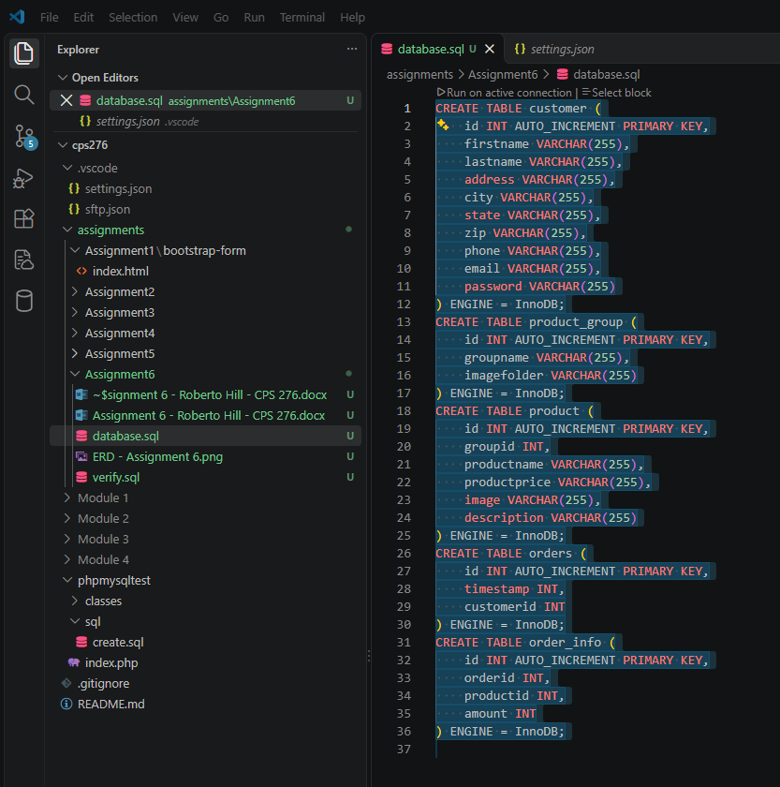
=
=

SHOW TABLES;
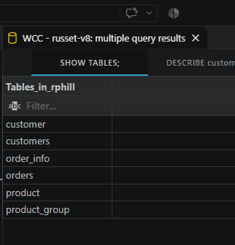
=

DESCRIBE customer;
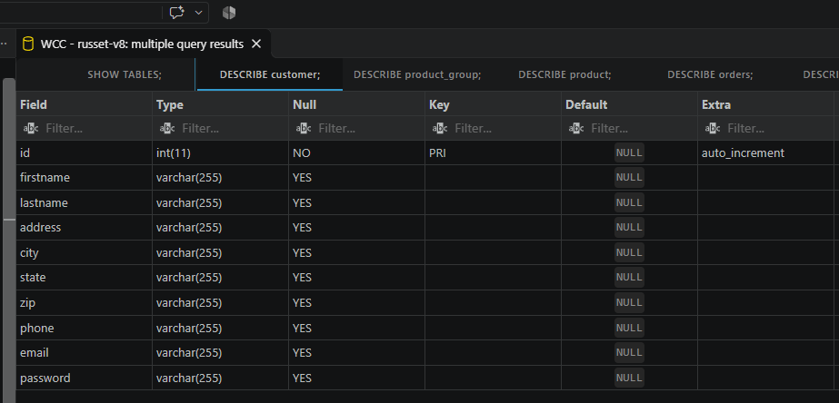
=

DESCRIBE product_group;
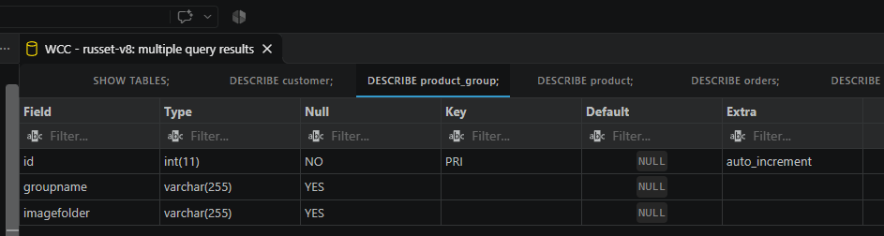
=

DESCRIBE product;
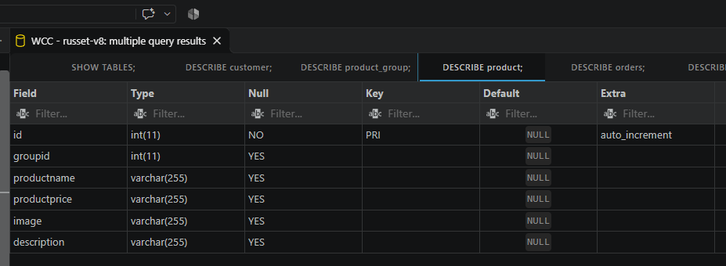
=

DESCRIBE orders;
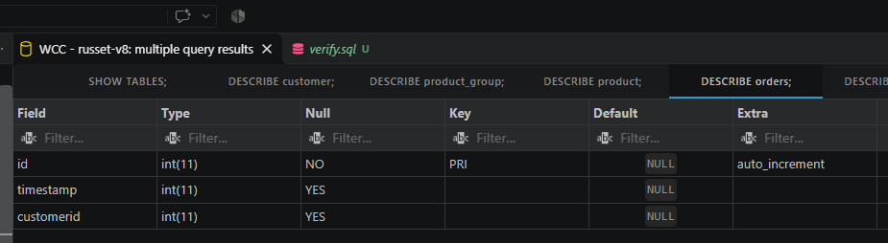
=

DESCRIBE order_info;
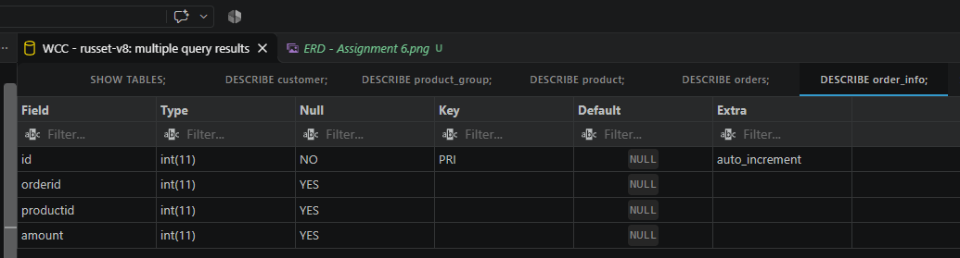
=

SHOW TABLE STATUS WHERE Name = 'customer';
=
=
=
=
=
=

